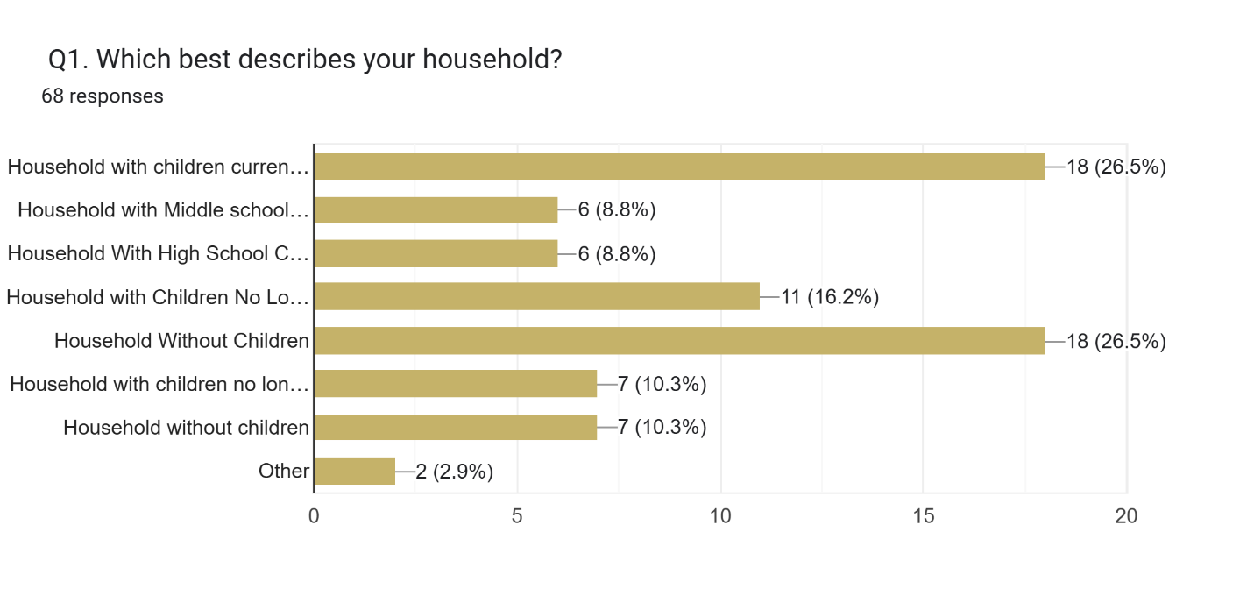
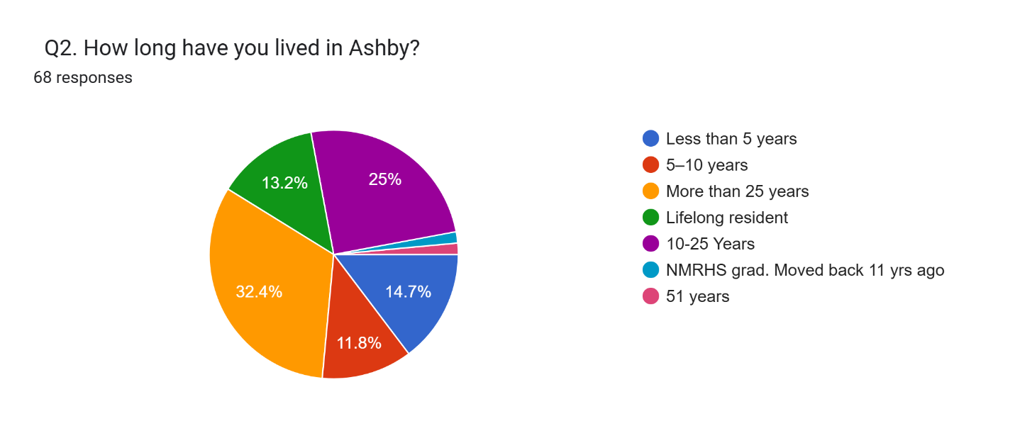
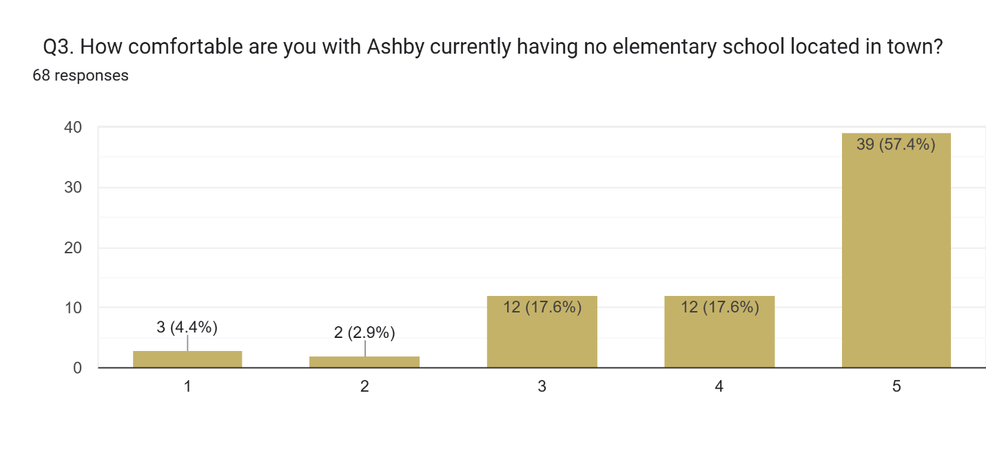
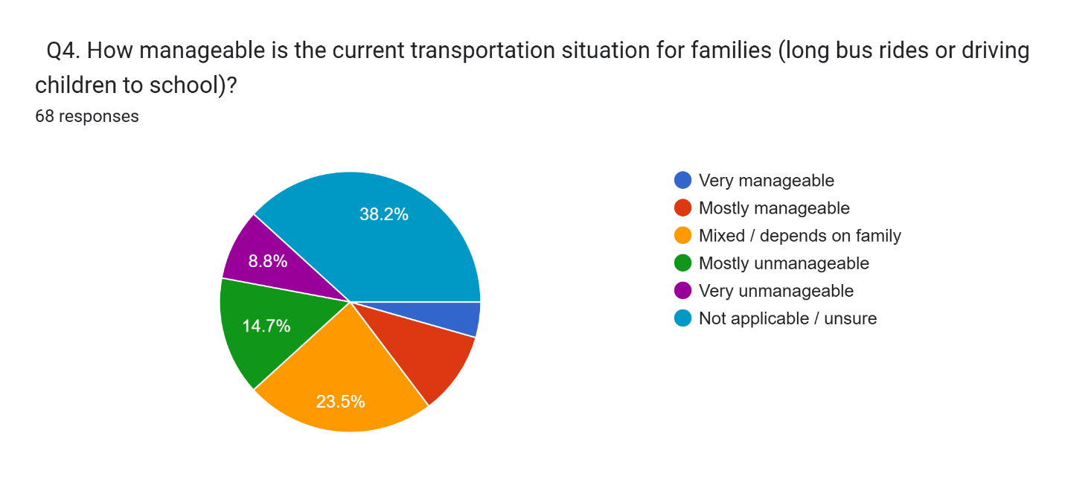
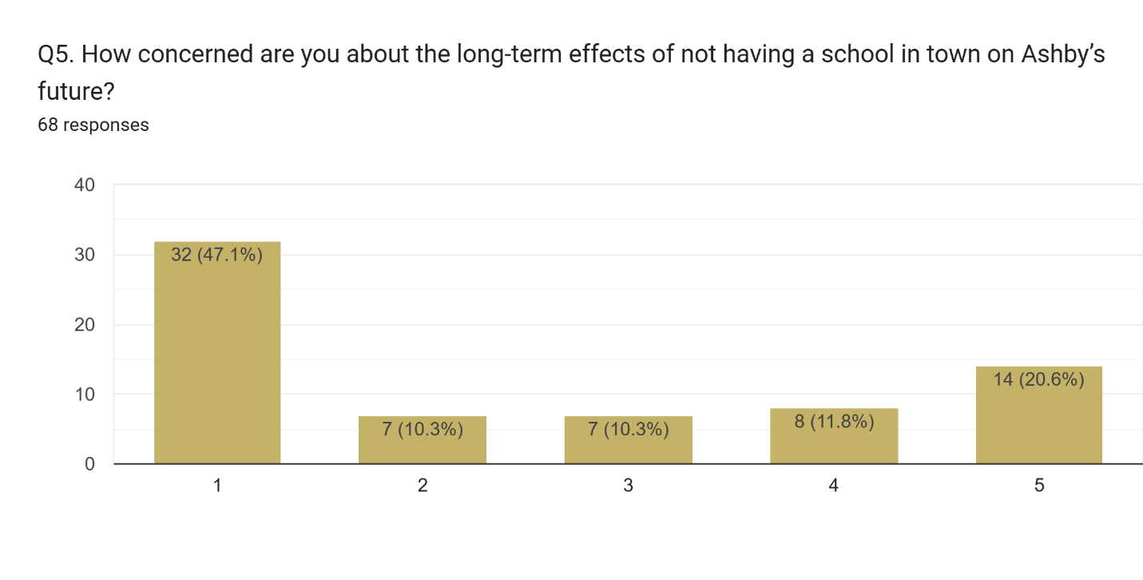
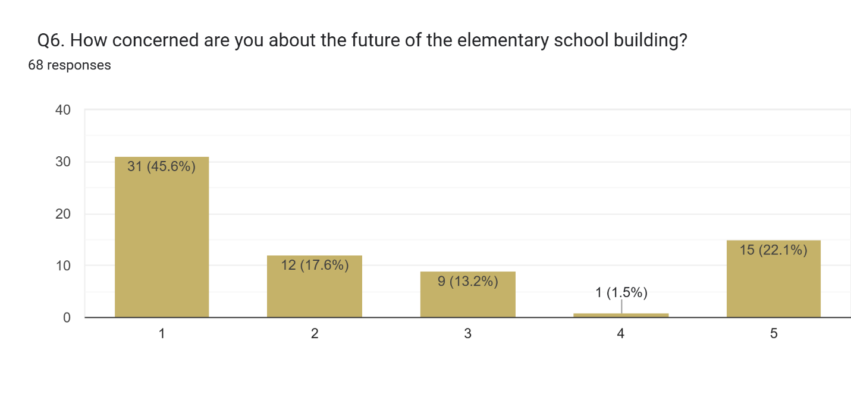

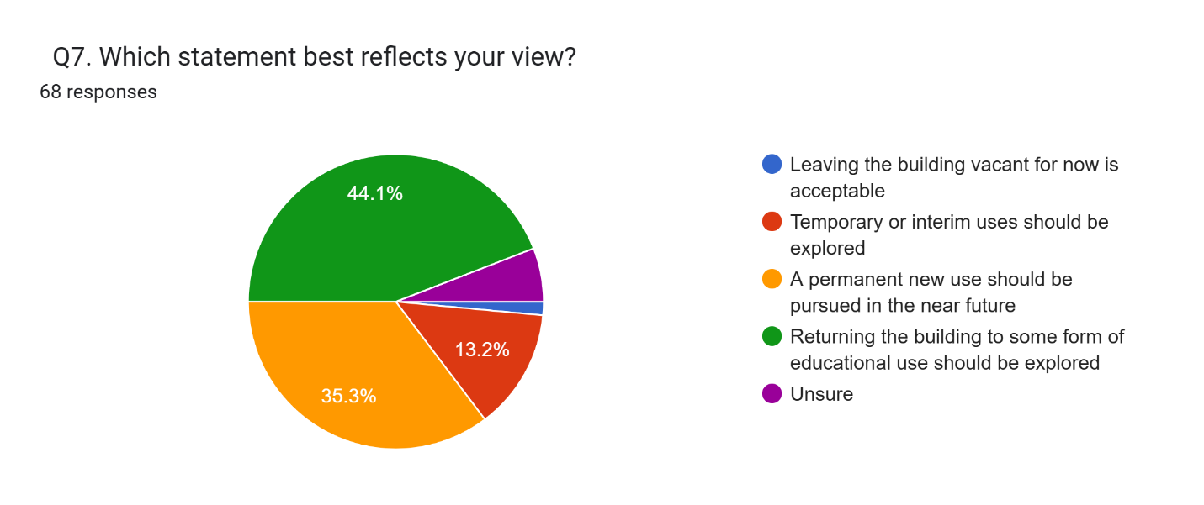
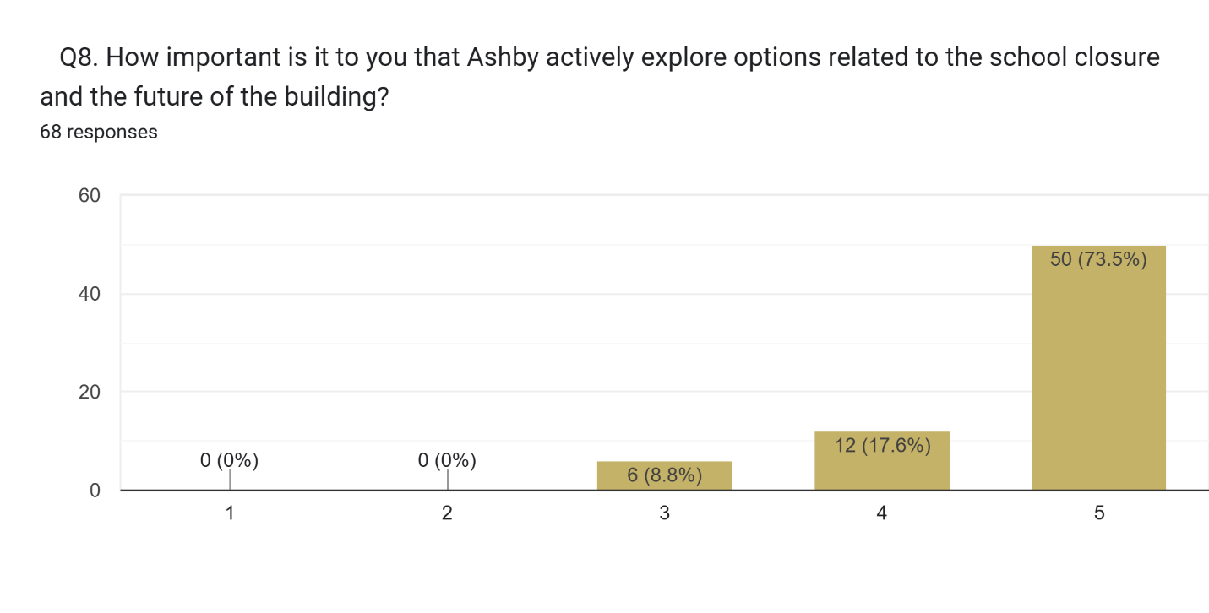
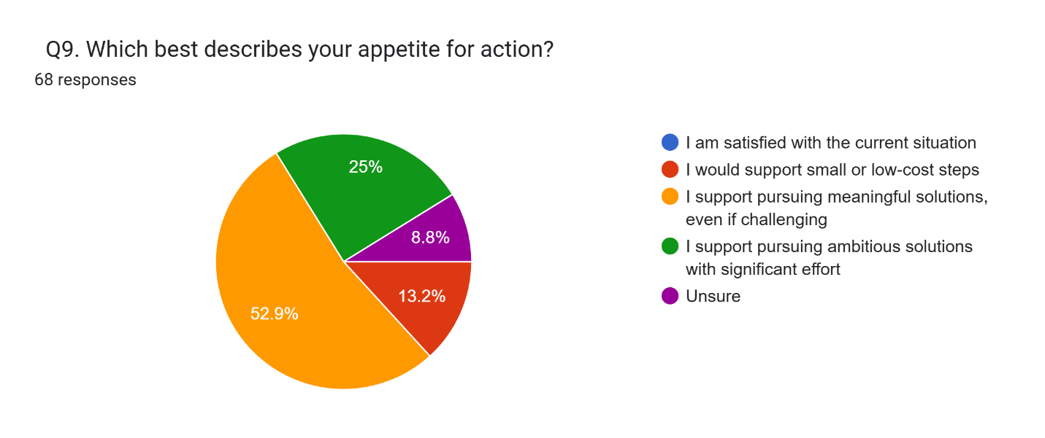
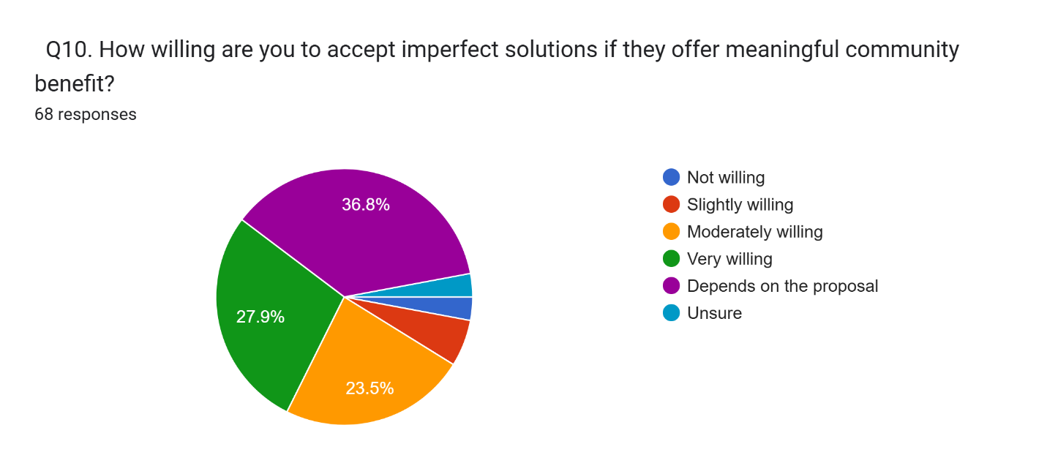
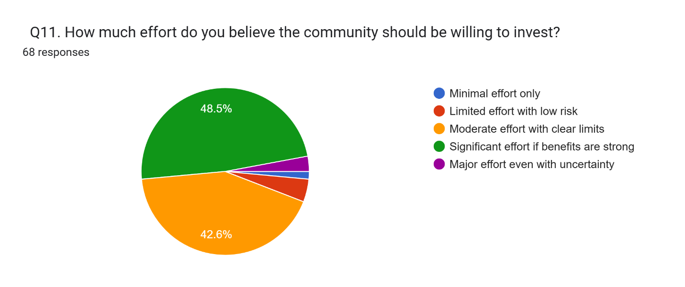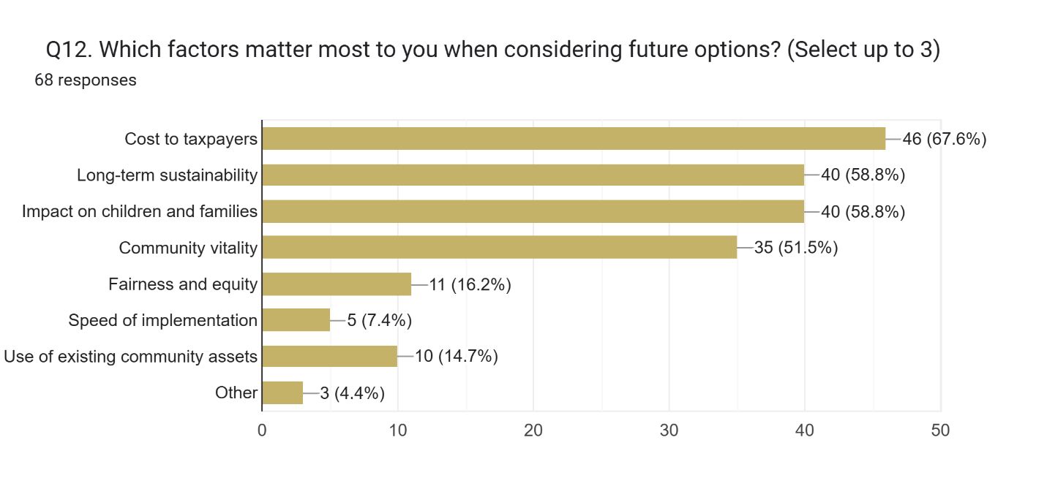
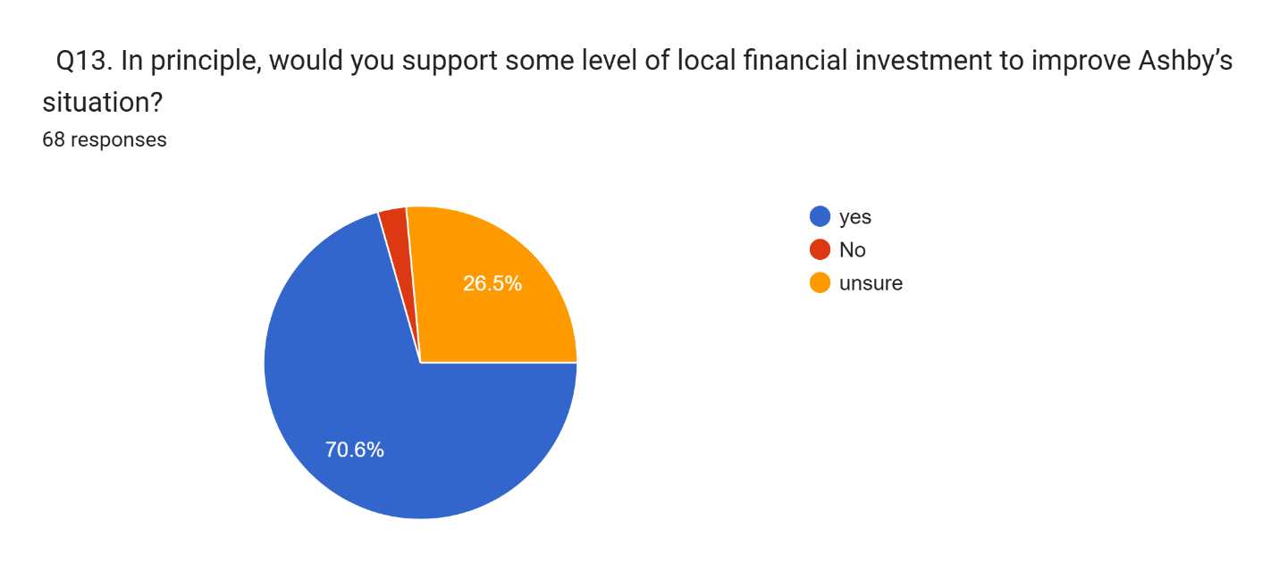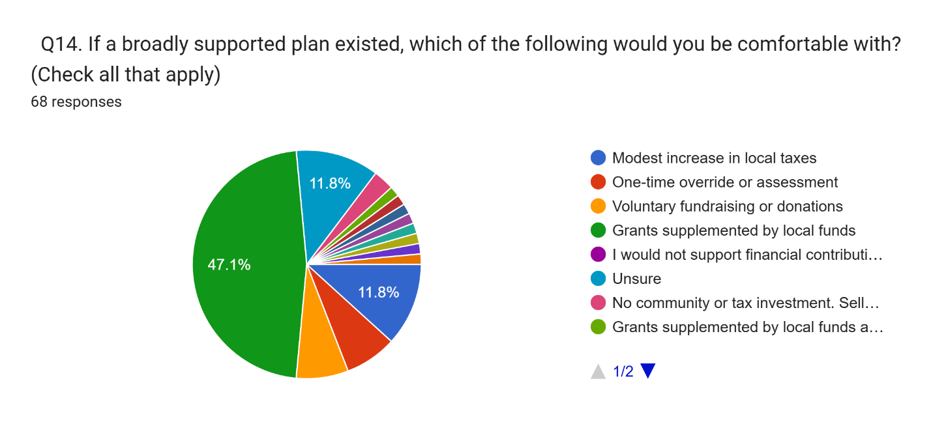
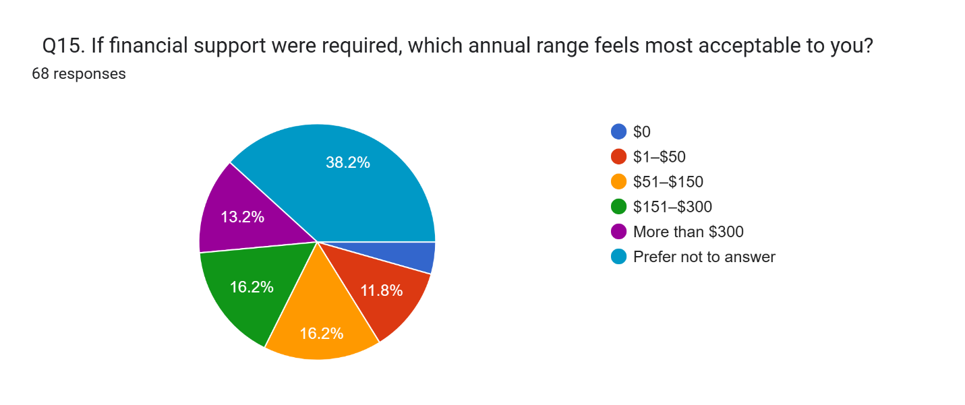
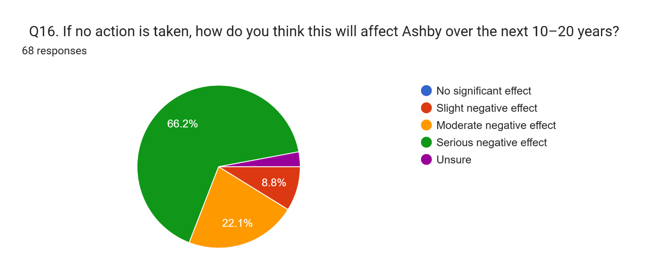
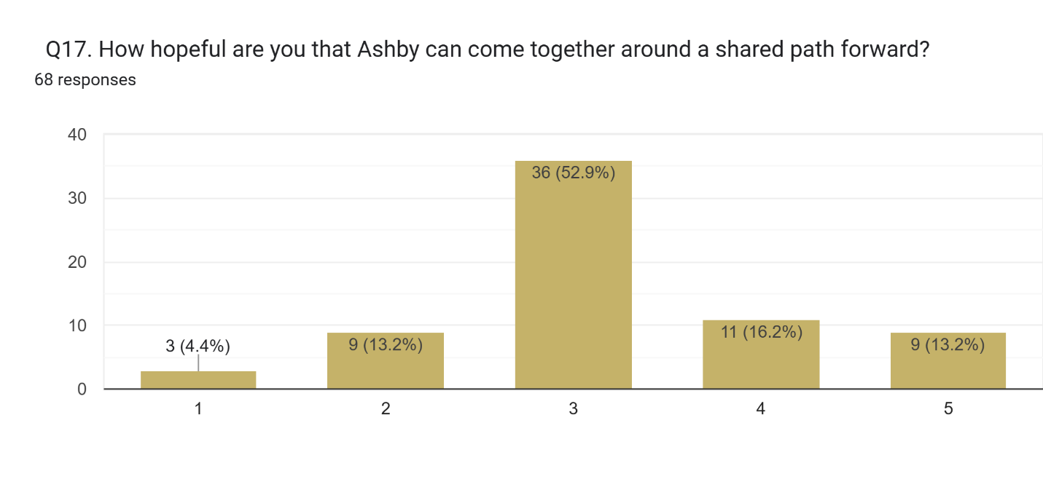
Q18. What do you most want decision-makers to understand about how this situation affects you or Ashby?
Decision-makers need to understand that the school closure is not just a budget or operational issue—it is a defining moment for Ashby’s future. An elementary school is core community infrastructure. Its loss affects children’s daily well-being, family decisions about moving to or staying in town, property values, the tax base, and Ashby’s identity as a vibrant, livable community. Leaving the building vacant carries real financial and social costs, including deterioration of a highly visible town asset and a negative signal to prospective residents. Whether the outcome is reopening a school or repurposing the building, swift and intentional action is essential. The goal must be maximum long-term benefit for the entire town: supporting children and families, stabilizing property values and taxes, strengthening community connection, and ensuring this asset contributes to Ashby’s vitality rather than accelerating decline.

Q19. Are there ideas or possibilities you would like explored, even if they may be difficult or expensive?
Residents want the town to explore all reasonable and creative options for the former school building, with strong support for solutions that either return education to Ashby or put the property back into active, revenue-generating use. Many favor educational pathways first, including reopening the school, attracting a charter or private school, creating a specialized special education or alternative program, a Pre-K center, homeschool hub, vocational or trade school, or even a magnet or district-wide specialty program.
If traditional schooling is not feasible, there is broad interest in mixed-use redevelopment, combining community space with uses that generate income—such as senior or income-restricted housing, small businesses, nonprofit or arts organizations, childcare or senior day programs, and leased office or startup space. A community center or recreation hub (using the gym, fields, playgrounds, and meeting spaces) is repeatedly cited as a way to serve residents of all ages while keeping the building active.
Many residents emphasize the need to make the building financially sustainable, through rentals, partnerships, grants, or private investment, to offset the residential tax burden. Some suggest learning from other towns’ successful reuse projects, while a smaller group believes selling or demolishing the building should be considered if reuse is not viable.
Across viewpoints, there is strong consensus on two points: the building cannot remain vacant, and the town should move quickly, transparently, and creatively to pursue options that maximize long-term community benefit, economic stability, and Ashby’s future vitality.

