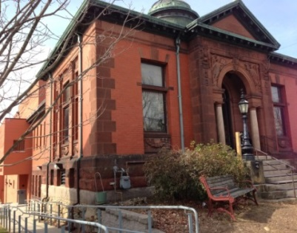
Meeting Notice
The Trustees of the Ashby Free Public Library will hold its regular monthly meeting under Governor Baker’s COVID-19 Open Meeting Law directive via zoom video conferencing on Wednesday, January 22, 2021, starting at 5:30 p.m. Follow the instructions below the agenda for joining the meeting.
Agenda:
- Call to order
- Review of minutes of December 22, 2021
- Receipt from the Director Search Committee of a strong recommendation to hire Heather Brodie Perry as permanent Director of the Library
  - Vote on Recommendation to hire
- Scholarship Report -
  - Revisit decision to give scholarship to board members. – tabled at last meeting
- Treasurer Report
  - Budget for FY2023 submitted to the town.
- Report by Building Maintenance Committee
  - Estimate for painting downstairs “staff” room
  - More estimates for painting the outside of the new building
  - Estimate for painting outside wooden window frames on old building
  - Painting completed for study room and downstairs hall
  - Downstairs “trash exit” door now locks
  - Dehumidifier
  - Air purification
  - Snow and ice removal from walkways
  - No Parking sign installed
- Report on Friends of AFPL
- Director’s Report
- Chair requests Board to reinstitute the position of Financial Treasurer
- Other business not anticipated by the Chair
- Adjourn

Join the Zoom Meeting using the link below or by joining the meeting ID
https://us02web.zoom.us/j/85380671482
Meeting ID: 853 8067 1482
Dial in: +1 929 205 6099

